|  |  |  |  |  |  |
| --- | --- | --- | --- | --- | --- |
| Date | September 27, 2022 | | | Tester Name | Alyssa Johnson |
| Environment | Penfax - Test | | | Login used |  |
| Operating System | Select OS | Version: | Update: | | |
| Software Used | Select Software | Version: | Update: | | |
| Select Software | Version: | Update: | | |
| Release version | 22.3.0 | | | | |
| Title | E23.03 | | | | |
| Test Type | Regression | | | | |
| Test Scenario | Process Year End Batch (December Age 72 and above catchup withdrawal batch) | | | | |
|  |  | | | | |
| Expected Results | That batch will run & members will be paid their remaining minimum amount  Compare the amount is correct on several members that were paid in this batch in comparison to the Age 72 min report. Confirm - No regularly scheduled payments (ITA, or fixed) should be part of this batch.  Confirm member with:   * members age as min factor * spouses age (under 72) used as min factor * spouses age (over 72) used as min factor * mbr who has taken out some money this year, (just not enough to satisfy minimum) | | | | |
| Pass/Fail | Pass | | | JIRA# | N/A |

Step 1: Check the plan parameters to see when scheduled withdrawals should run:

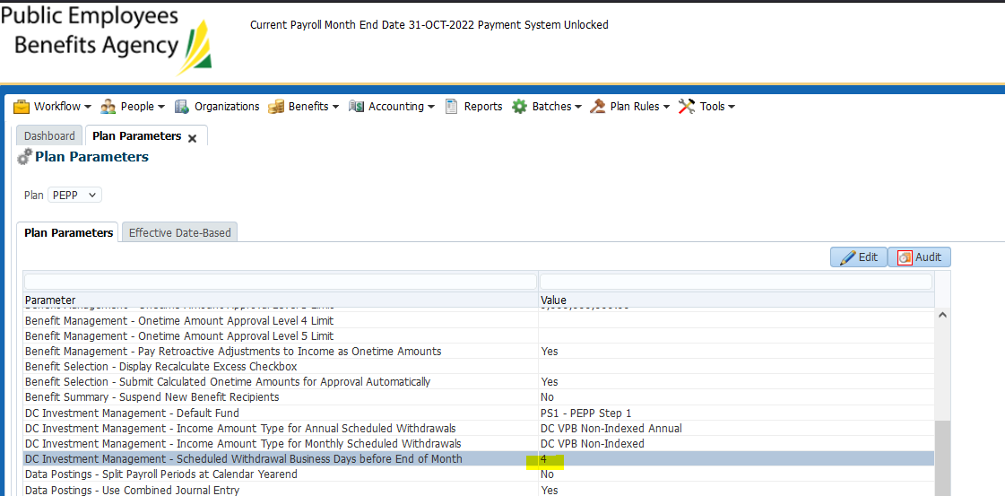

Use the date that is 4 business day’s before the end of the month (for December of the current year in next step):

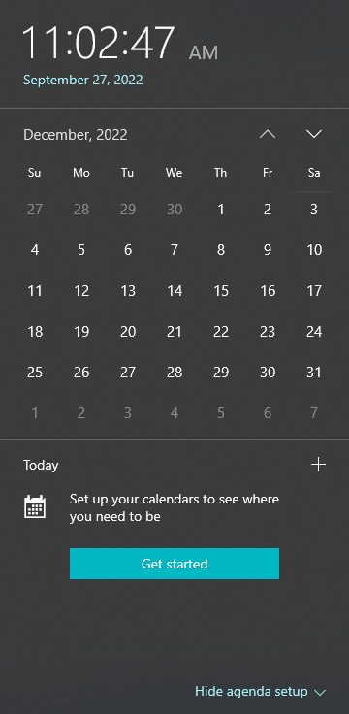

Counting 4 business days = 27,28,29,30 none of those days are stats or blackout days) so we use the business day before that (26th and 23rd are stats so use the 22nd)

*\*check stats over Christmas in Tools/blackout days*

Declare unit values for the date that is the night before the # business days in the plan parameters, (declare values for Dec 22, 2022):

Go to plan Rules/DC fund management (had to change all my unit value dates to Dec 26th):

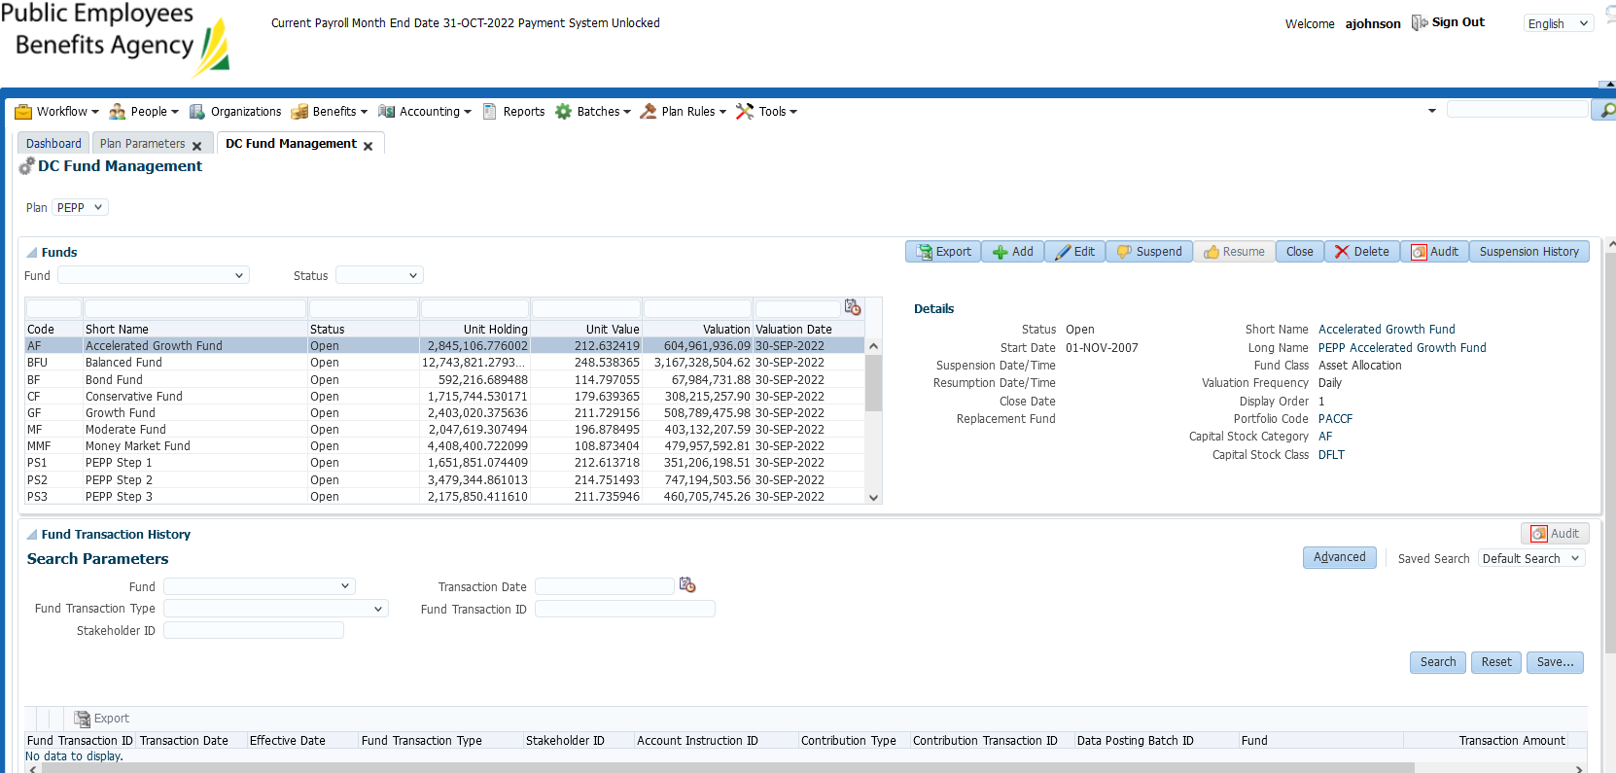

Scroll down & export unit values (this is so that when we add new one’s for Dec 22th they are reasonable unit values):

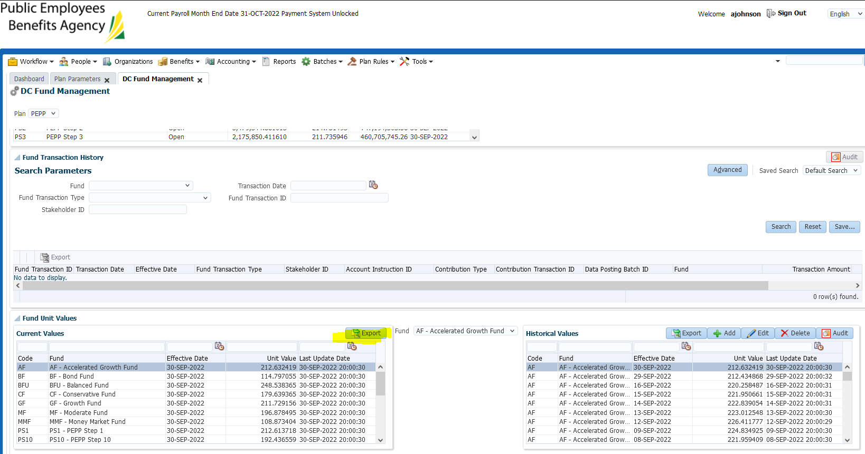

select fund from drop down box. Once selected click on add (it’s greyed out until the fund is selected in the drop down box):

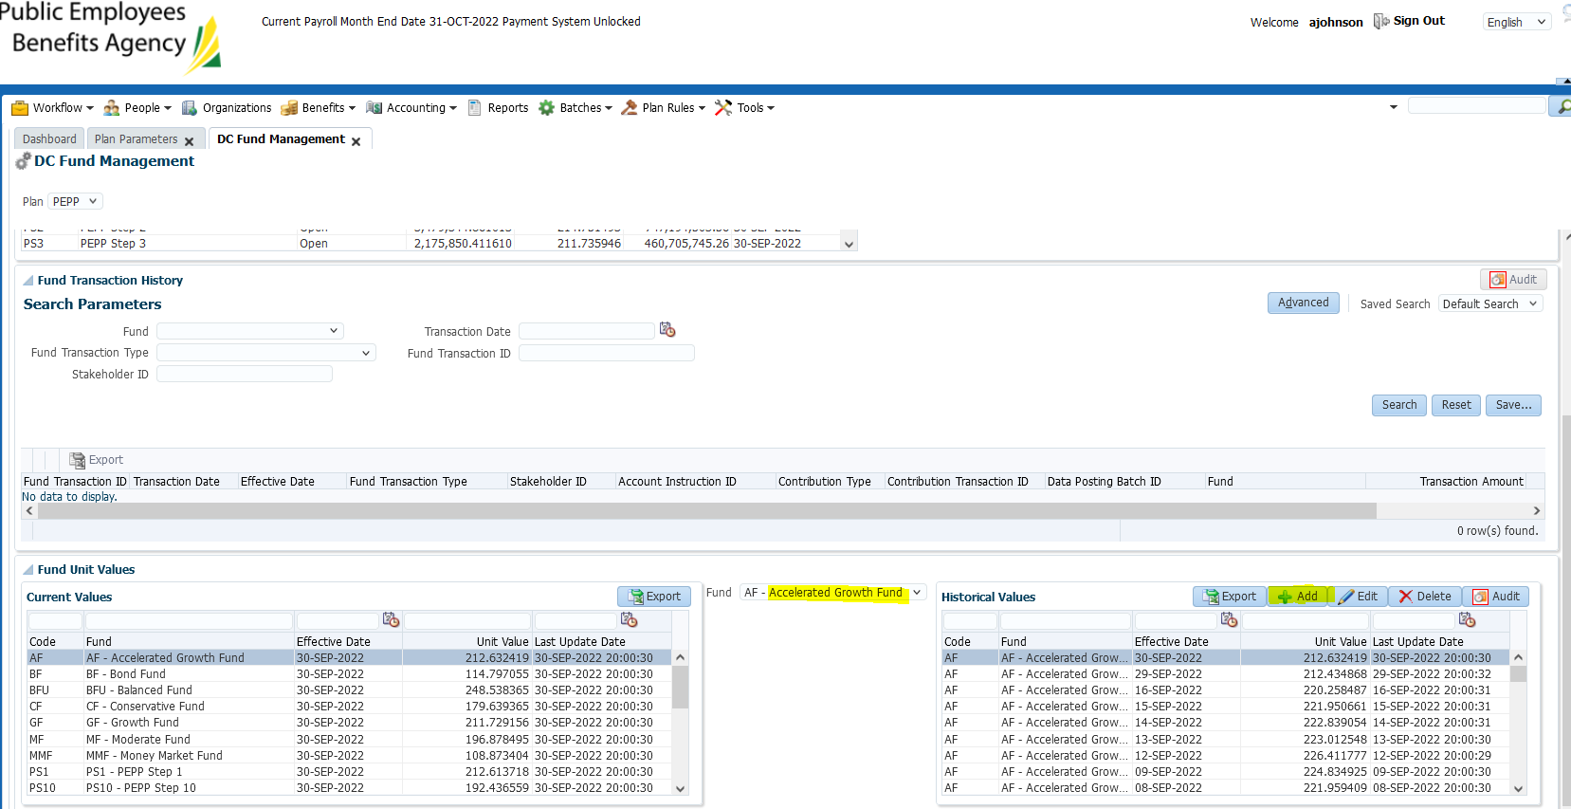

Complete the “add” step for each fund:

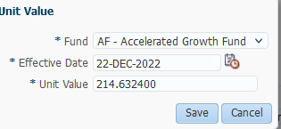

Ensure some unit values go up and other unit values go down. All unit values now show on the right hand side with an effective date of Dec 22th for All funds.

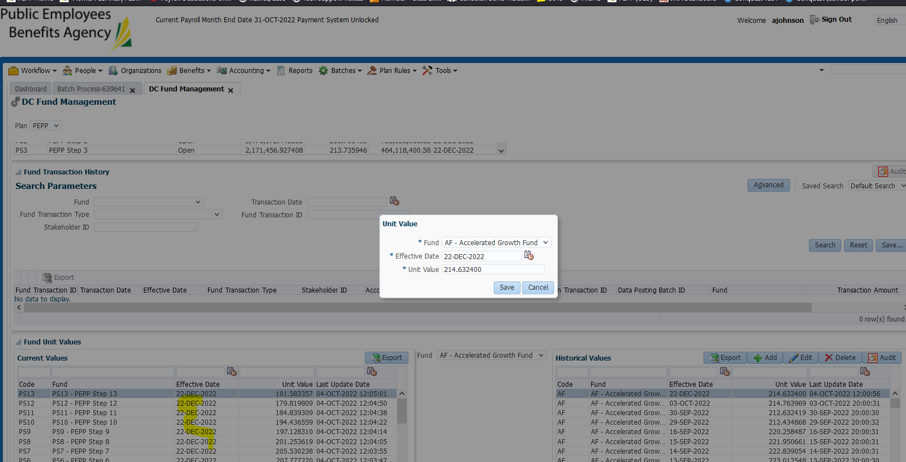

Pull Age 72 Report:

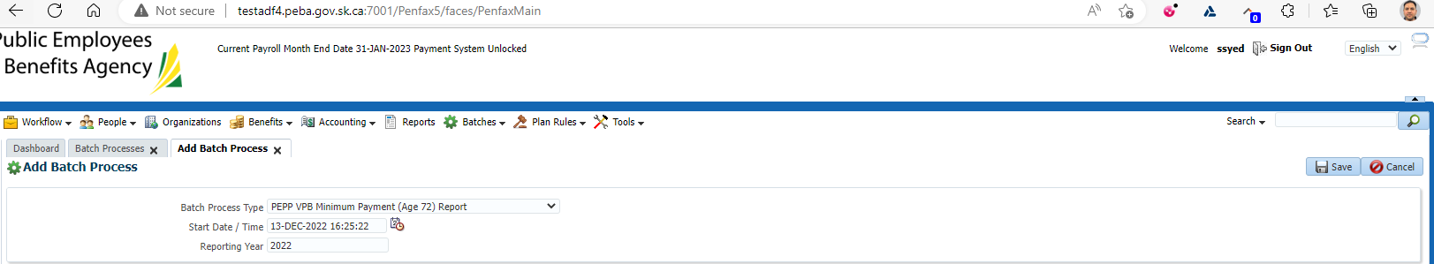

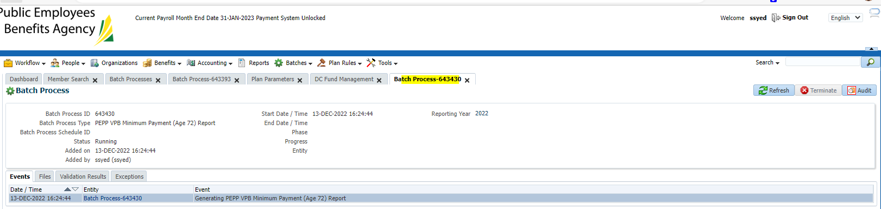

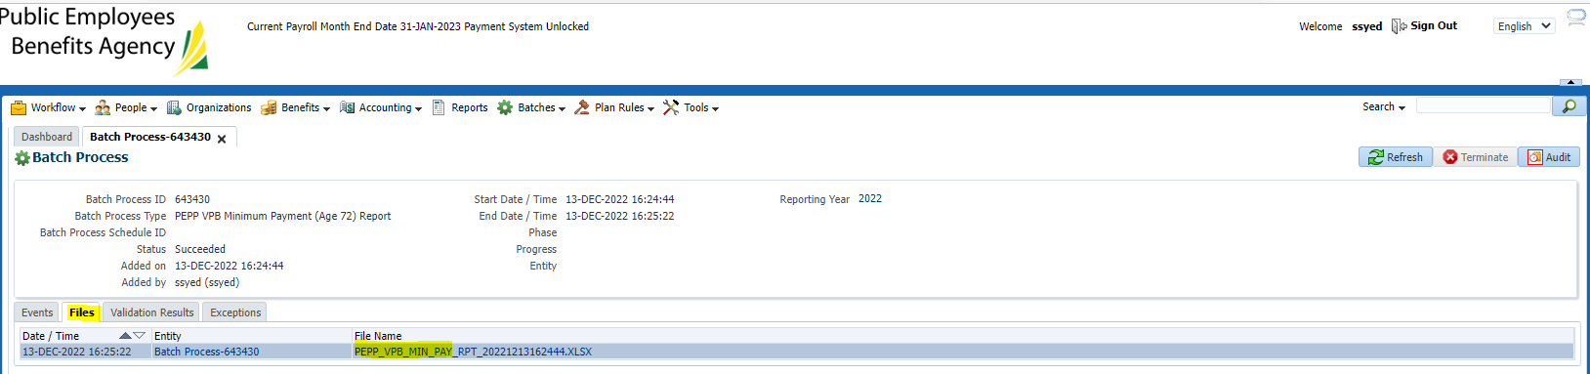

Run the December batch. Go to batches, add batch process then enter information and press save.

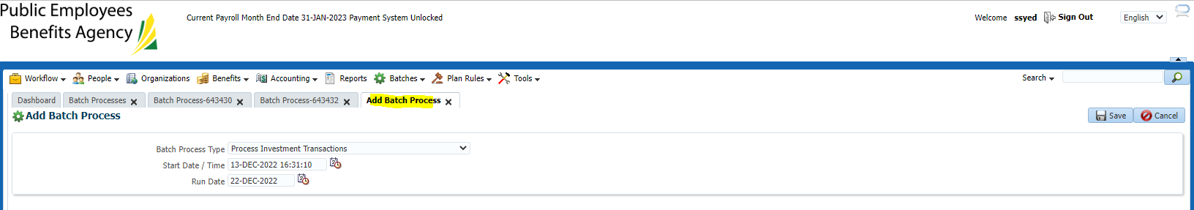

Refresh until it says completed successfully.

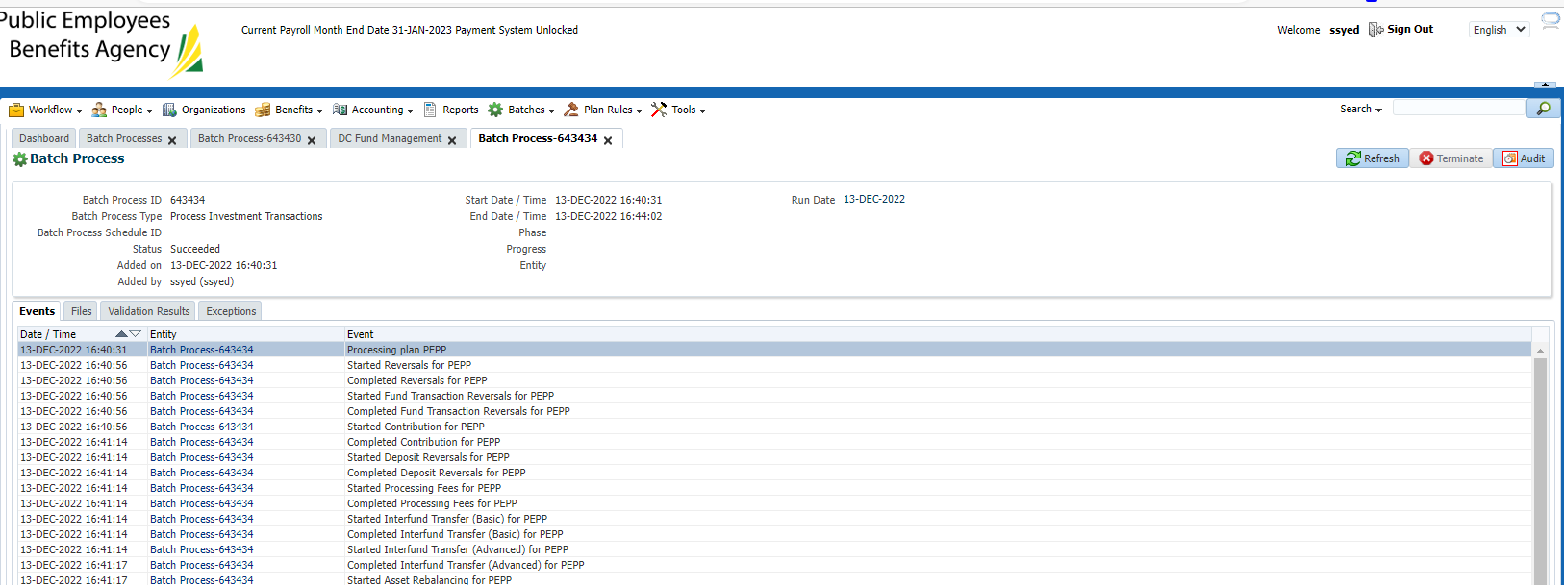

Found a person on the minimum payment list who would be getting a catchup payment:

Looking for a few members where the YTD withdrawal is less than the minimum requirement column.

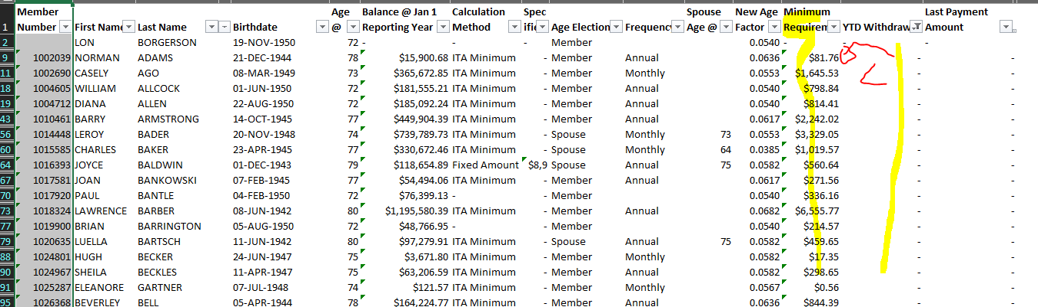

SID 237526 – Ago, Casley (Members Age)

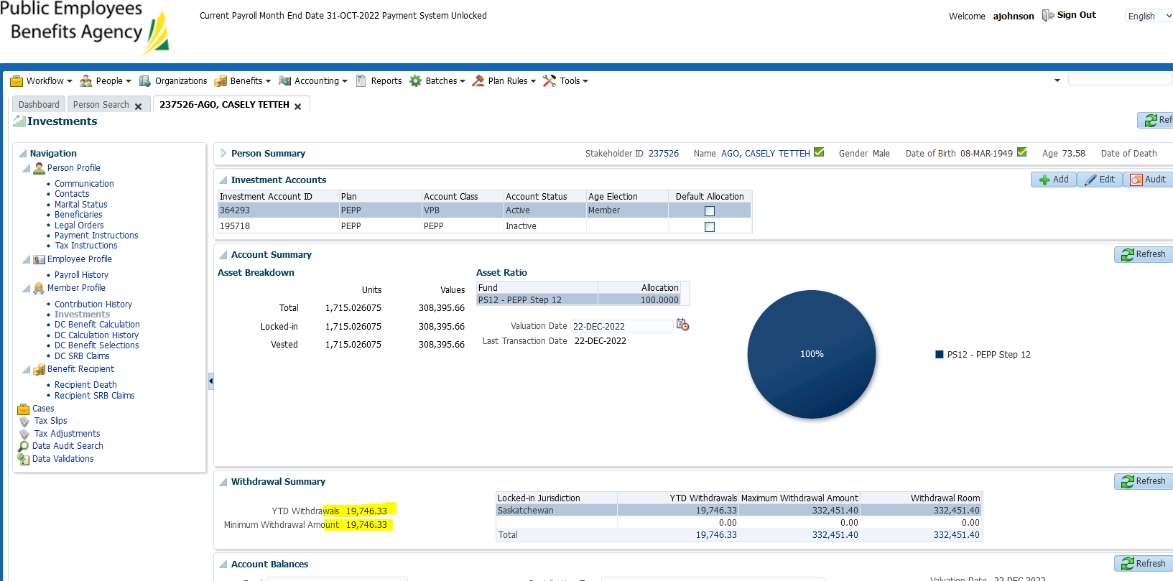

Withdrawal matches unit values declared for Dec 22

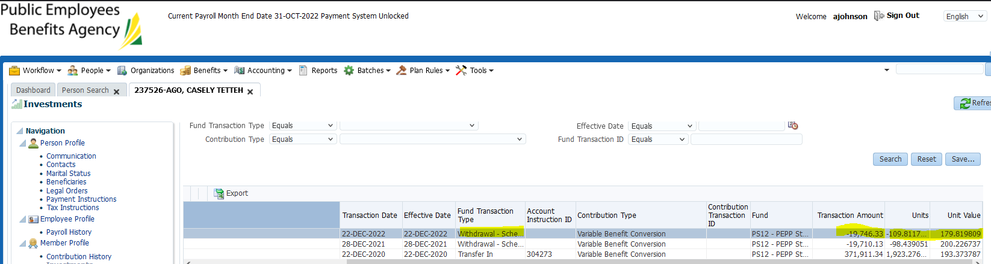



Checking minimum age factor *factors change every year:

<https://pepp.peba.ca/sites/pepp/files/2022-03/PEPP%20Talk%20Variable%20Pension%20Benefit_0.pdf>

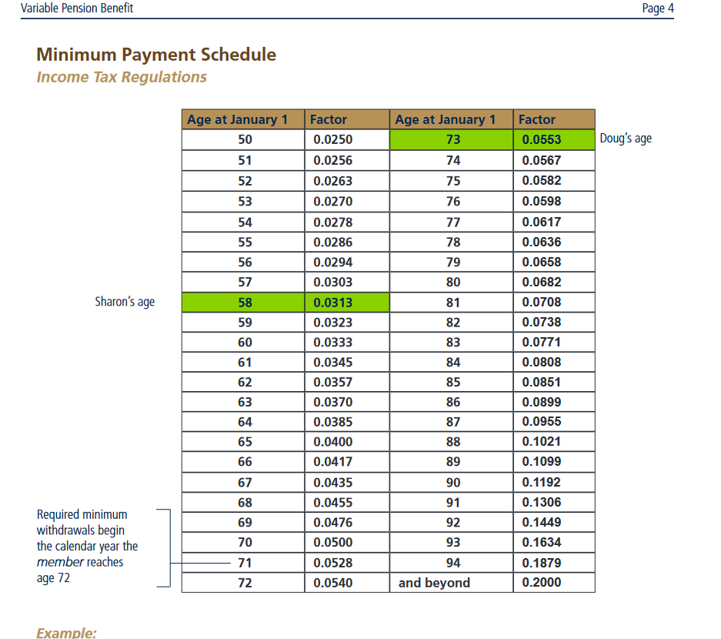

Age of Casley at January 1, 2022 was 72 (turned 73 in march)

Account balance at Jan 1 = 365,672.85

Age factor @72 = 0.0540

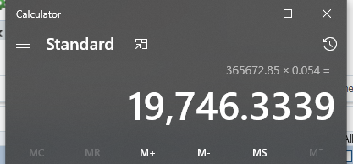  
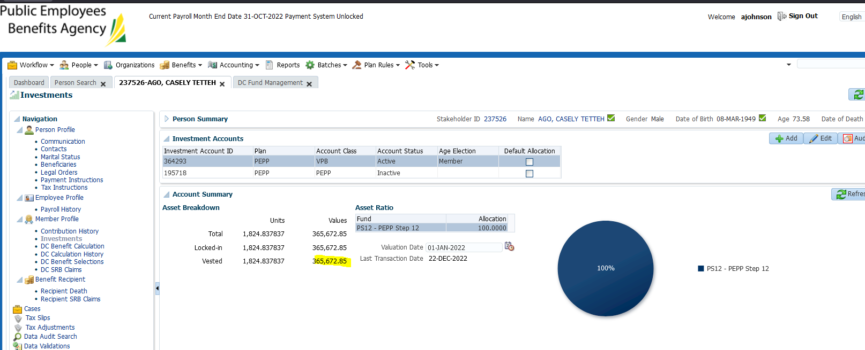

Factor used matches amount w/d in catchup batch.

Check after Overnight batch then will check benefit recipient for taxes/pmt ID

SID: 238348 - Baker, Charles – using spouses age (spouse under 72)

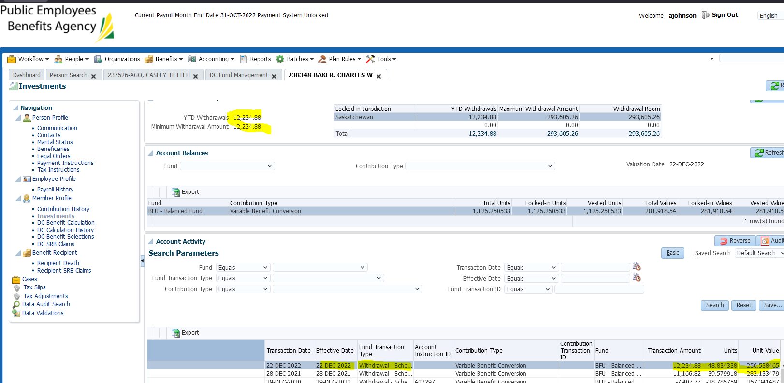

Spouses age at Jan 1, 2022 was 63 (turned 64 in Feb)

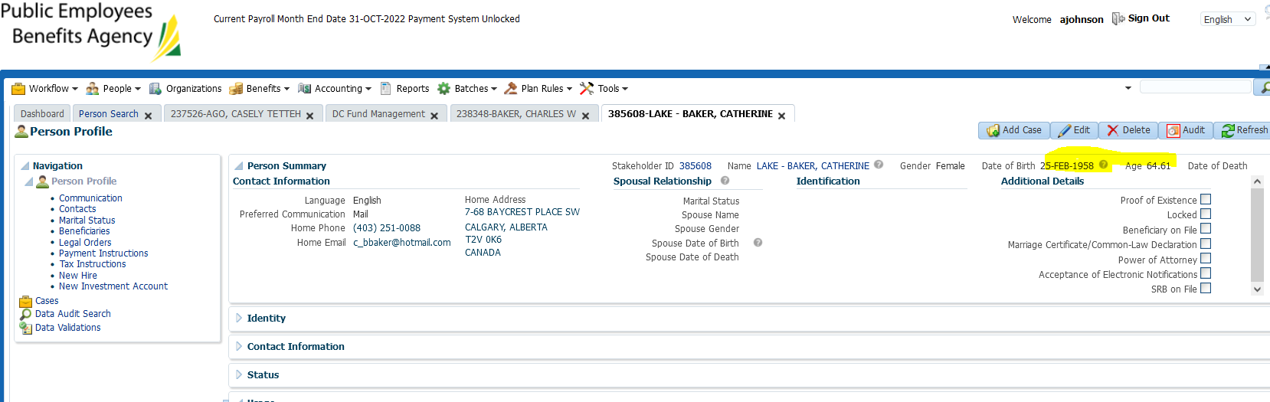

Factor= 3.70%



Account balance at Jan 1, 2022

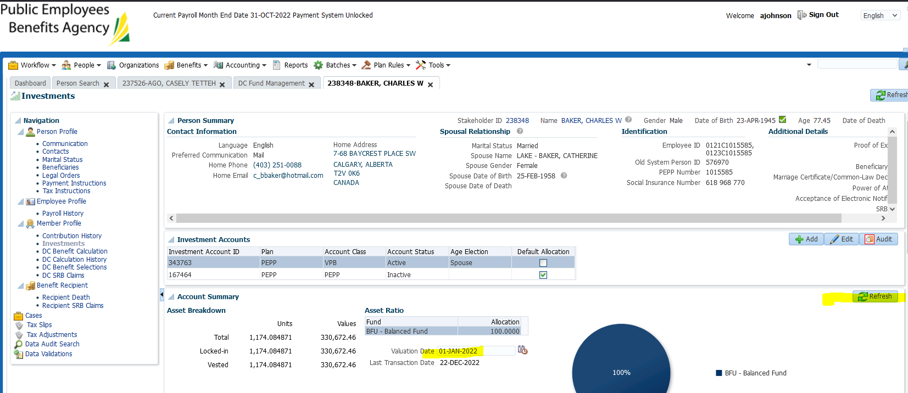

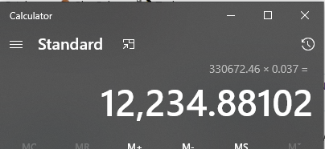

Check after overnight batch to confirm pmt/processing in benefit recipient

SID: 295864

Next Day: Change current month end date to Dec 31st and run payroll in payment production

